**In order to achieve the assessment criteria (P6) you must answer the following task:**

**Task 1**

Explain briefly the following types of programmable logic devices:

* PAL.
* GAL.
* CPLD

**(P6)**

**In order to achieve the assessment criteria (P7) you must answer the following task:**

**Task 2**

Evaluate the following sequential circuits in figure 1 and figure 2

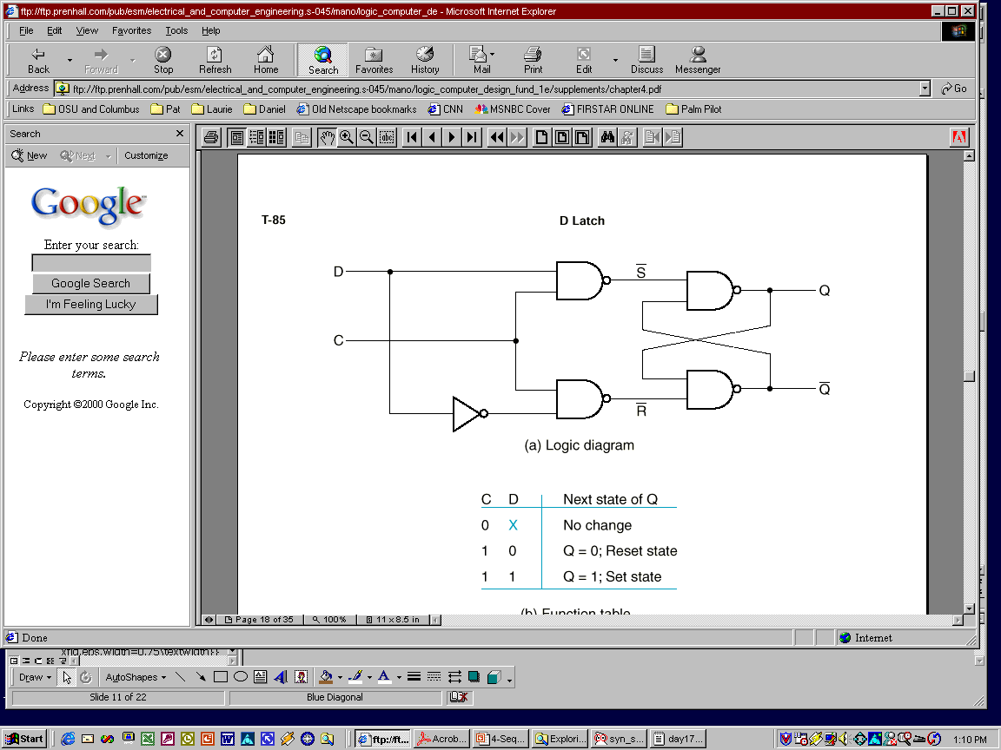

Fig (1)

Fig (2)

**(P7)**